A Decade of TPC-C

By Francois J. Raab

Introduction
In the summer of 1992, close to a decade ago, the Transaction processing Performance Council (TPC) release a new OLTP benchmark under the name TPC Benchmark™ C or TPC-C. While the TPC is now exploring the definition of a new and cutting edge OLTP benchmark, it is an appropriate time to look back and learn a lesson or two from 9 years of TPC-C publications.
This paper will look at the TPC-C legacy from several angles in an attempt to answer the following questions:
- What trends can we derive from the volume and content of result publications?
- What has been learned about OLTP systems through standard testing?
- What has been the impact of standard benchmarks on the competitive landscape?
- What have been the benefits to IT users?
In conclusion, this paper will present the current status of the new OLTP benchmark under development in the TPC.

Publication Trends
This section will examine the body of TPC-C results published to date and derive broad trends.
The following graphs illustrate examples of the trends that will be examined.

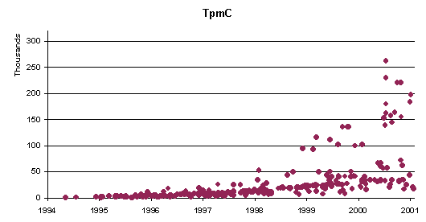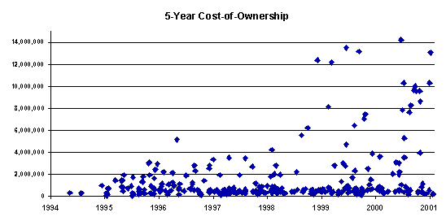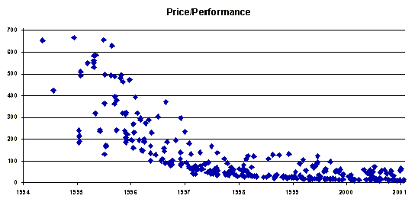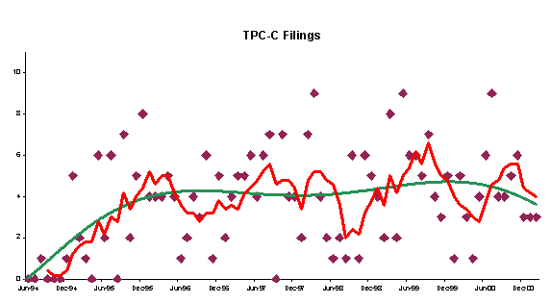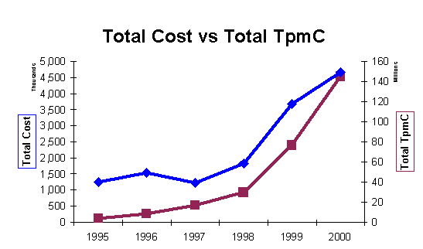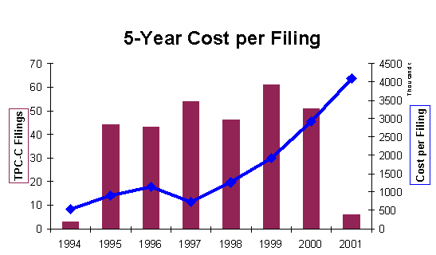

Lessons From Testing
This section will outline the most significant lessons learned through the participation of all predominant OLTP vendors in a regulated competitive race.
Examples of the lessons that will be outlined are the important role of the TP Monitor, the client/server model, the predominance of the DBMS, the gravitation toward commodity, etc.

Competitive Landscape
This section will discuss the changes in the OLTP landscape over the last decade and how some of these changes were impacted by TPC benchmarking.
Examples of the changes that will be discussed are the rise and fall of DBMS vendors, the consolidation of system vendors, the flirt with 4GL, the essence of the benchmarking game, etc.

The Benefits To Users
This section will develop the idea that the biggest winner in the TPC-C race has been the IT user community.
This idea will be supported by the dramatic drop in price/performance, the convergence toward commodity components, and the generic definition of enterprise computing capabilities.

Conclusion – The Next OLTP Benchmark
By conference time I expect to be able to present the current status of the TPC proposal for a new OLTP benchmark.
This will be an opportunity for the panel to discuss the proposal and influence the directions of the new design.
.

